PIZZA SALES SQL QUERIES

1. KPI’s
2. **Total Revenue:**

SELECT SUM(total_price) AS Total_Revenue FROM pizza_sales;

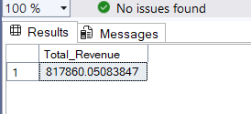

1. **Average Order Value**

SELECT (SUM(total_price) / COUNT(DISTINCT order_id)) AS Avg_order_Value FROM pizza_sales

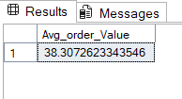

1. **Total Pizzas Sold**

SELECT SUM(quantity) AS Total_pizza_sold FROM pizza_sales

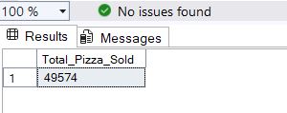

1. **Total Orders**

SELECT COUNT(DISTINCT order_id) AS Total_Orders FROM pizza_sales

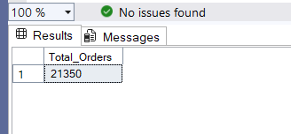

1. **Average Pizza Per Order**

SELECT CAST(CAST(SUM(quantity) AS DECIMAL(10,2)) /

CAST(COUNT(DISTINCT order_id) AS DECIMAL(10,2)) AS DECIMAL(10,2))

AS Avg_Pizzas_per_order

FROM pizza_sales

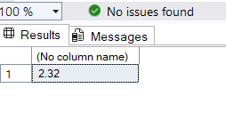

1. CHARTS
2. **Daily Trends**

SELECT DATENAME(DW, order_date) AS order_day, COUNT(DISTINCT order_id) AS total_orders

FROM pizza_sales

GROUP BY DATENAME(DW, order_date)

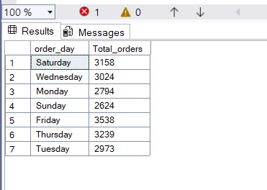

1. **Monthly Trend**

select datename(MONTH, order_date) as Month_Name, count(distinct order_id) as Total_orders

from pizza_sales

group by datename(MONTH, order_date)

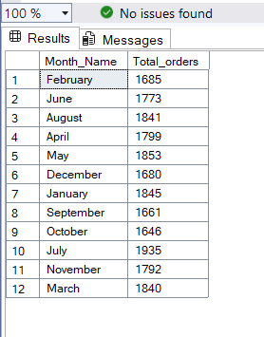

1. Category Percentage

select pizza_category, sum(total_price) * 100 / (select sum(total_price) from pizza_sales where month(order_date) = 1) as PCT_Total_Sales

from pizza_sales

where month(order_date) = 1

group by pizza_category

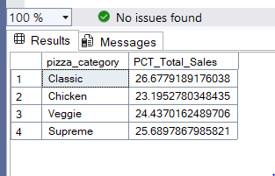

1. Pizza size Percentage

select pizza_size, cast(sum(total_price) * 100 / (select sum(total_price) from pizza_sales where DATEPART(quarter, order_date) = 1) as decimal(10,2)) as PCT_Total_Sales

from pizza_sales

where DATEPART(quarter, order_date) = 1

group by pizza_size

order by PCT_Total_Sales desc

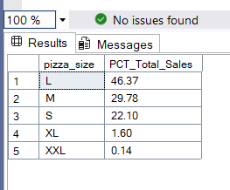

1. **Total Pizzas Sold by Pizza Category**

SELECT pizza_category, SUM(quantity) as Total_Quantity_Sold

FROM pizza_sales

WHERE MONTH(order_date) = 2

GROUP BY pizza_category

ORDER BY Total_Quantity_Sold DESC

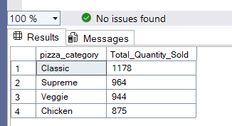

1. **Top 5 Pizza by Revenue**

SELECT Top 5 pizza_name, SUM(total_price) AS Total_Revenue

FROM pizza_sales

GROUP BY pizza_name

ORDER BY Total_Revenue DESC

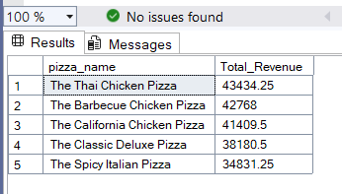

1. **Bottom 5 Pizza by Revenue**

SELECT Top 5 pizza_name, SUM(total_price) AS Total_Revenue

FROM pizza_sales

GROUP BY pizza_name

ORDER BY Total_Revenue ASC

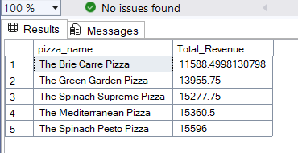

1. **Top 5 Pizzas by Quantity**

SELECT Top 5 pizza_name, SUM(quantity) AS Total_Pizza_Sold

FROM pizza_sales

GROUP BY pizza_name

ORDER BY Total_Pizza_Sold DESC

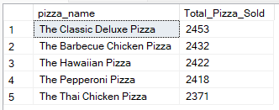

1. **Bottom 5 Pizzas by Quantity**

SELECT TOP 5 pizza_name, SUM(quantity) AS Total_Pizza_Sold

FROM pizza_sales

GROUP BY pizza_name

ORDER BY Total_Pizza_Sold ASC

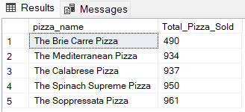

1. **Top 5 Pizzas by Total Orders**

SELECT Top 5 pizza_name, COUNT(DISTINCT order_id) AS Total_Orders

FROM pizza_sales

GROUP BY pizza_name

ORDER BY Total_Orders DESC

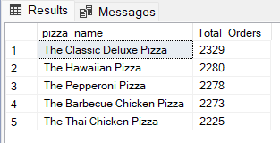

1. **Borrom 5 Pizzas by Total Orders**

SELECT Top 5 pizza_name, COUNT(DISTINCT order_id) AS Total_Orders

FROM pizza_sales

GROUP BY pizza_name

ORDER BY Total_Orders ASC

